Experiment 13: Host Discovery in Kali Linux
Aim
To perform host discovery in Kali Linux using Nmap to identify active hosts on a network.
Algorithm
- Start Kali Linux and open the terminal.
- Check whether Nmap is installed.
- Execute a host discovery command to check whether the target host is active.
- Perform a ping scan to discover active hosts on an authorized local network.
- Observe and record the results displayed in the terminal.
Commands and Uses
1. Check whether a host is active
nmap -sn 127.0.0.1
Use: Checks host availability without performing a port scan.
2. Discover hosts on a local network
nmap -sn 192.168.1.0/24
Use: Discovers responding hosts in the 192.168.1.0/24 network. Replace this network with your actual local subnet.
3. Check a specific host
ping -c 4 127.0.0.1
Use: Sends four ICMP echo requests to check connectivity with the local machine.
Sample Output
Starting Nmap
Nmap scan report for localhost (127.0.0.1)
Host is up.
Nmap done: 1 IP address scanned
Note: This is illustrative output. Actual results depend on the target and network configuration.
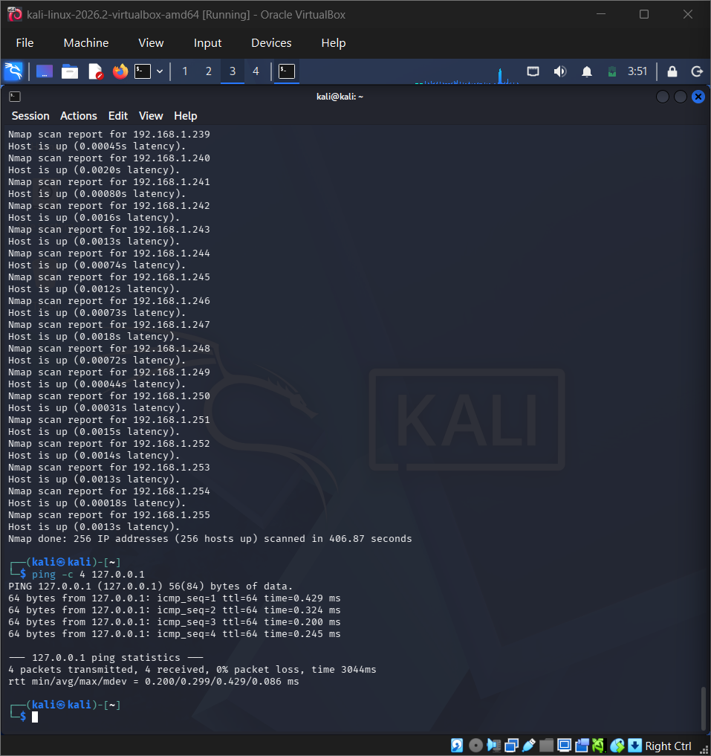
Result
Host discovery was demonstrated using Nmap in Kali Linux to identify active hosts on a network.
Safety: Perform scans only on your own network or systems for which you have permission.

